Annual Veterans Day Service

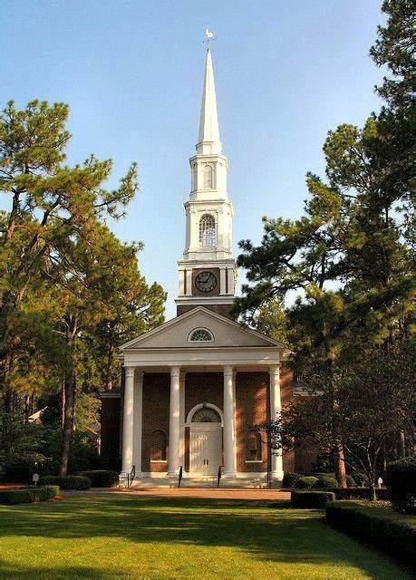

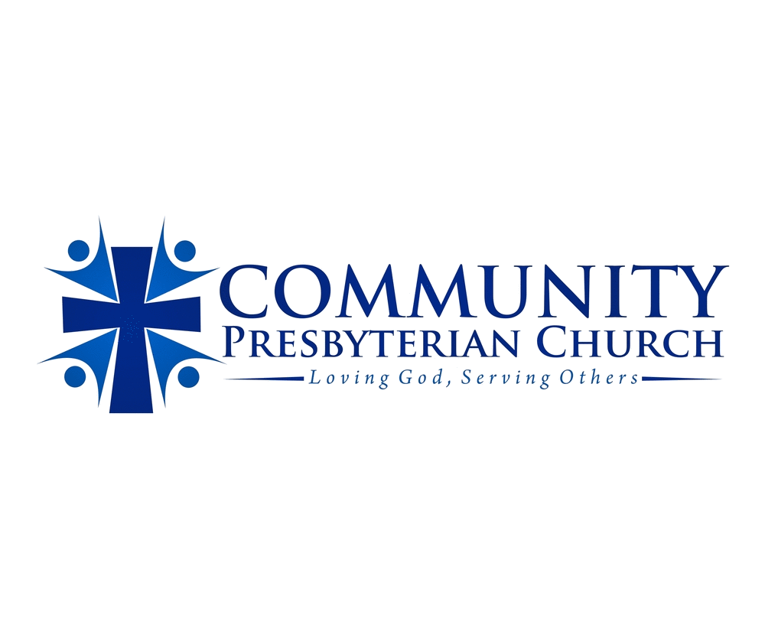
November 11th, 2025
Village Community Presbyterian Church
Starts at 11:00 am

